**Nanyang Coding Guidelines (Sec FW)**

1. **FW Architecture**

Layered FW architecture will benefit in generating libraries for different protocols and functions ( generate libraries can be further development plans)

Layered FW architecture eases design portability.

2-layer FW architecture is maintained for Nanyang sec FW.

Modular Programming style

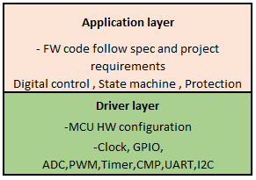

1. **Project file structure**

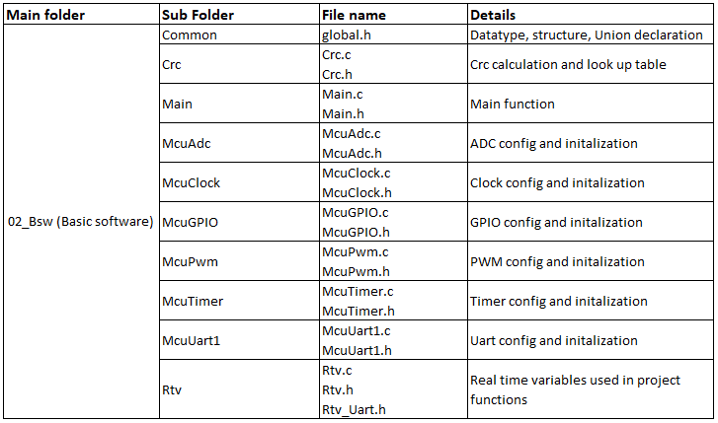

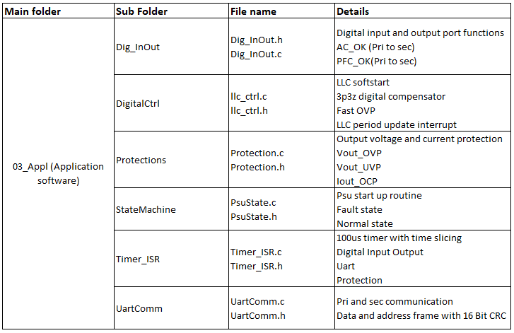

1. **Nomenclature (Internal)**
2. Datatype definition

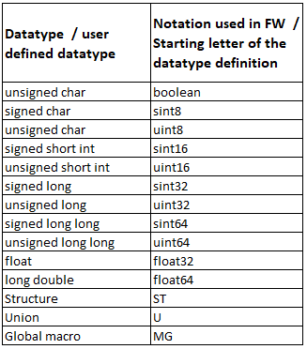

1. Variable declaration

